Press Release

Sindelfingen, October 19, 2026
Keep on bending: RAS Storage automatically feeds blanks to the Multibend-Center
Compact storage tower saves floor space, pallet changes without downtime
With RAS Storage, RAS Reinhardt Maschinenbau is introducing a new storage system for its Multibend-Center. It automatically supplies the machine with blanks, saves floor space and keeps the Multibend-Center bending even while pallets are being changed, making production even more economical.
Bending without interruption
The RAS Multibend-Center bends precision parts fully automatically, regardless of batch size. To ensure a continuous supply of material, RAS Storage combines storage and loading in a single system. Pallets are changed while the machine continues bending, so there is no downtime for material replenishment.
At the core of the system is a compact storage tower with six pallets that keeps the supply of blanks on a small footprint. Each pallet holds one to four stacks, and the blanks can be placed directly on the pallet. Euro and industrial pallets can be used as well.
With several stacks on hand, RAS Storage supports kit production, in which all blanks of a kit are bent in a single run. At the same time, the processing sequence remains flexible and can be adapted to the orders at hand.
Loading robot without programming or teaching
Loading is handled by a robot that requires neither programming nor teaching. It rotates and flips the blanks: they are stored visible side up and bent visible side down. If the blanks do not need to be flipped, a shuttle table supports loading. Automatic unloading is available as an option.
(1,453 characters incl. spaces, 236 words)
About RAS:
RAS Reinhardt Maschinenbau GmbH is one of the world’s leading manufacturers of innovative sheet metal working machinery. Based in Sindelfingen, Germany, the company has stood for quality and technical precision “Made in Germany” for more than 85 years. Its extensive portfolio includes folding machines, swing beam shears and forming machines, as well as automated and customized manufacturing solutions for a wide range of industries worldwide. With a strong focus on quality, reliability and technological innovation, RAS delivers solutions that meet the most demanding requirements.
(585 characters incl. spaces, 84 words)

Deeplinks:
www.ras-online.de/en/products/bending/multibend-center/

Images:
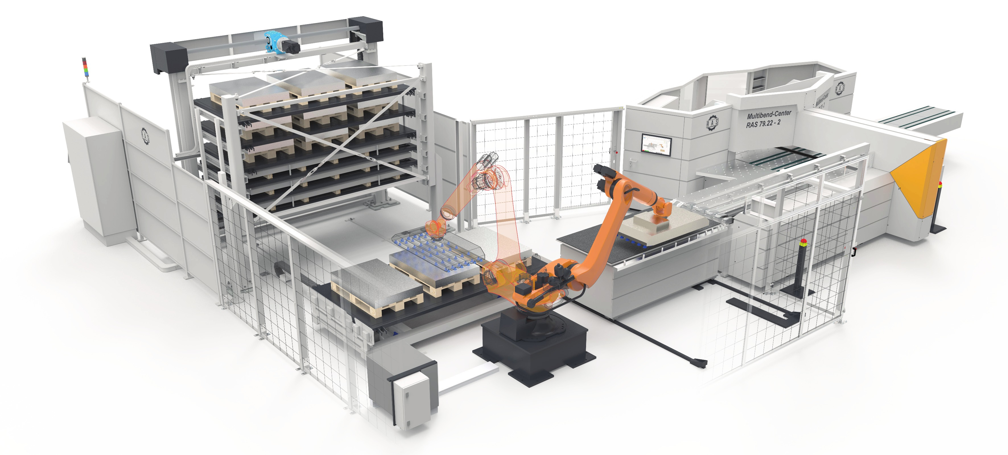
RAS-Storage_Gesamtansicht.jpg: RAS Storage with compact storage tower and loading robot, linked to the RAS Multibend-Center.
Source: RAS Reinhardt Maschinenbau GmbH

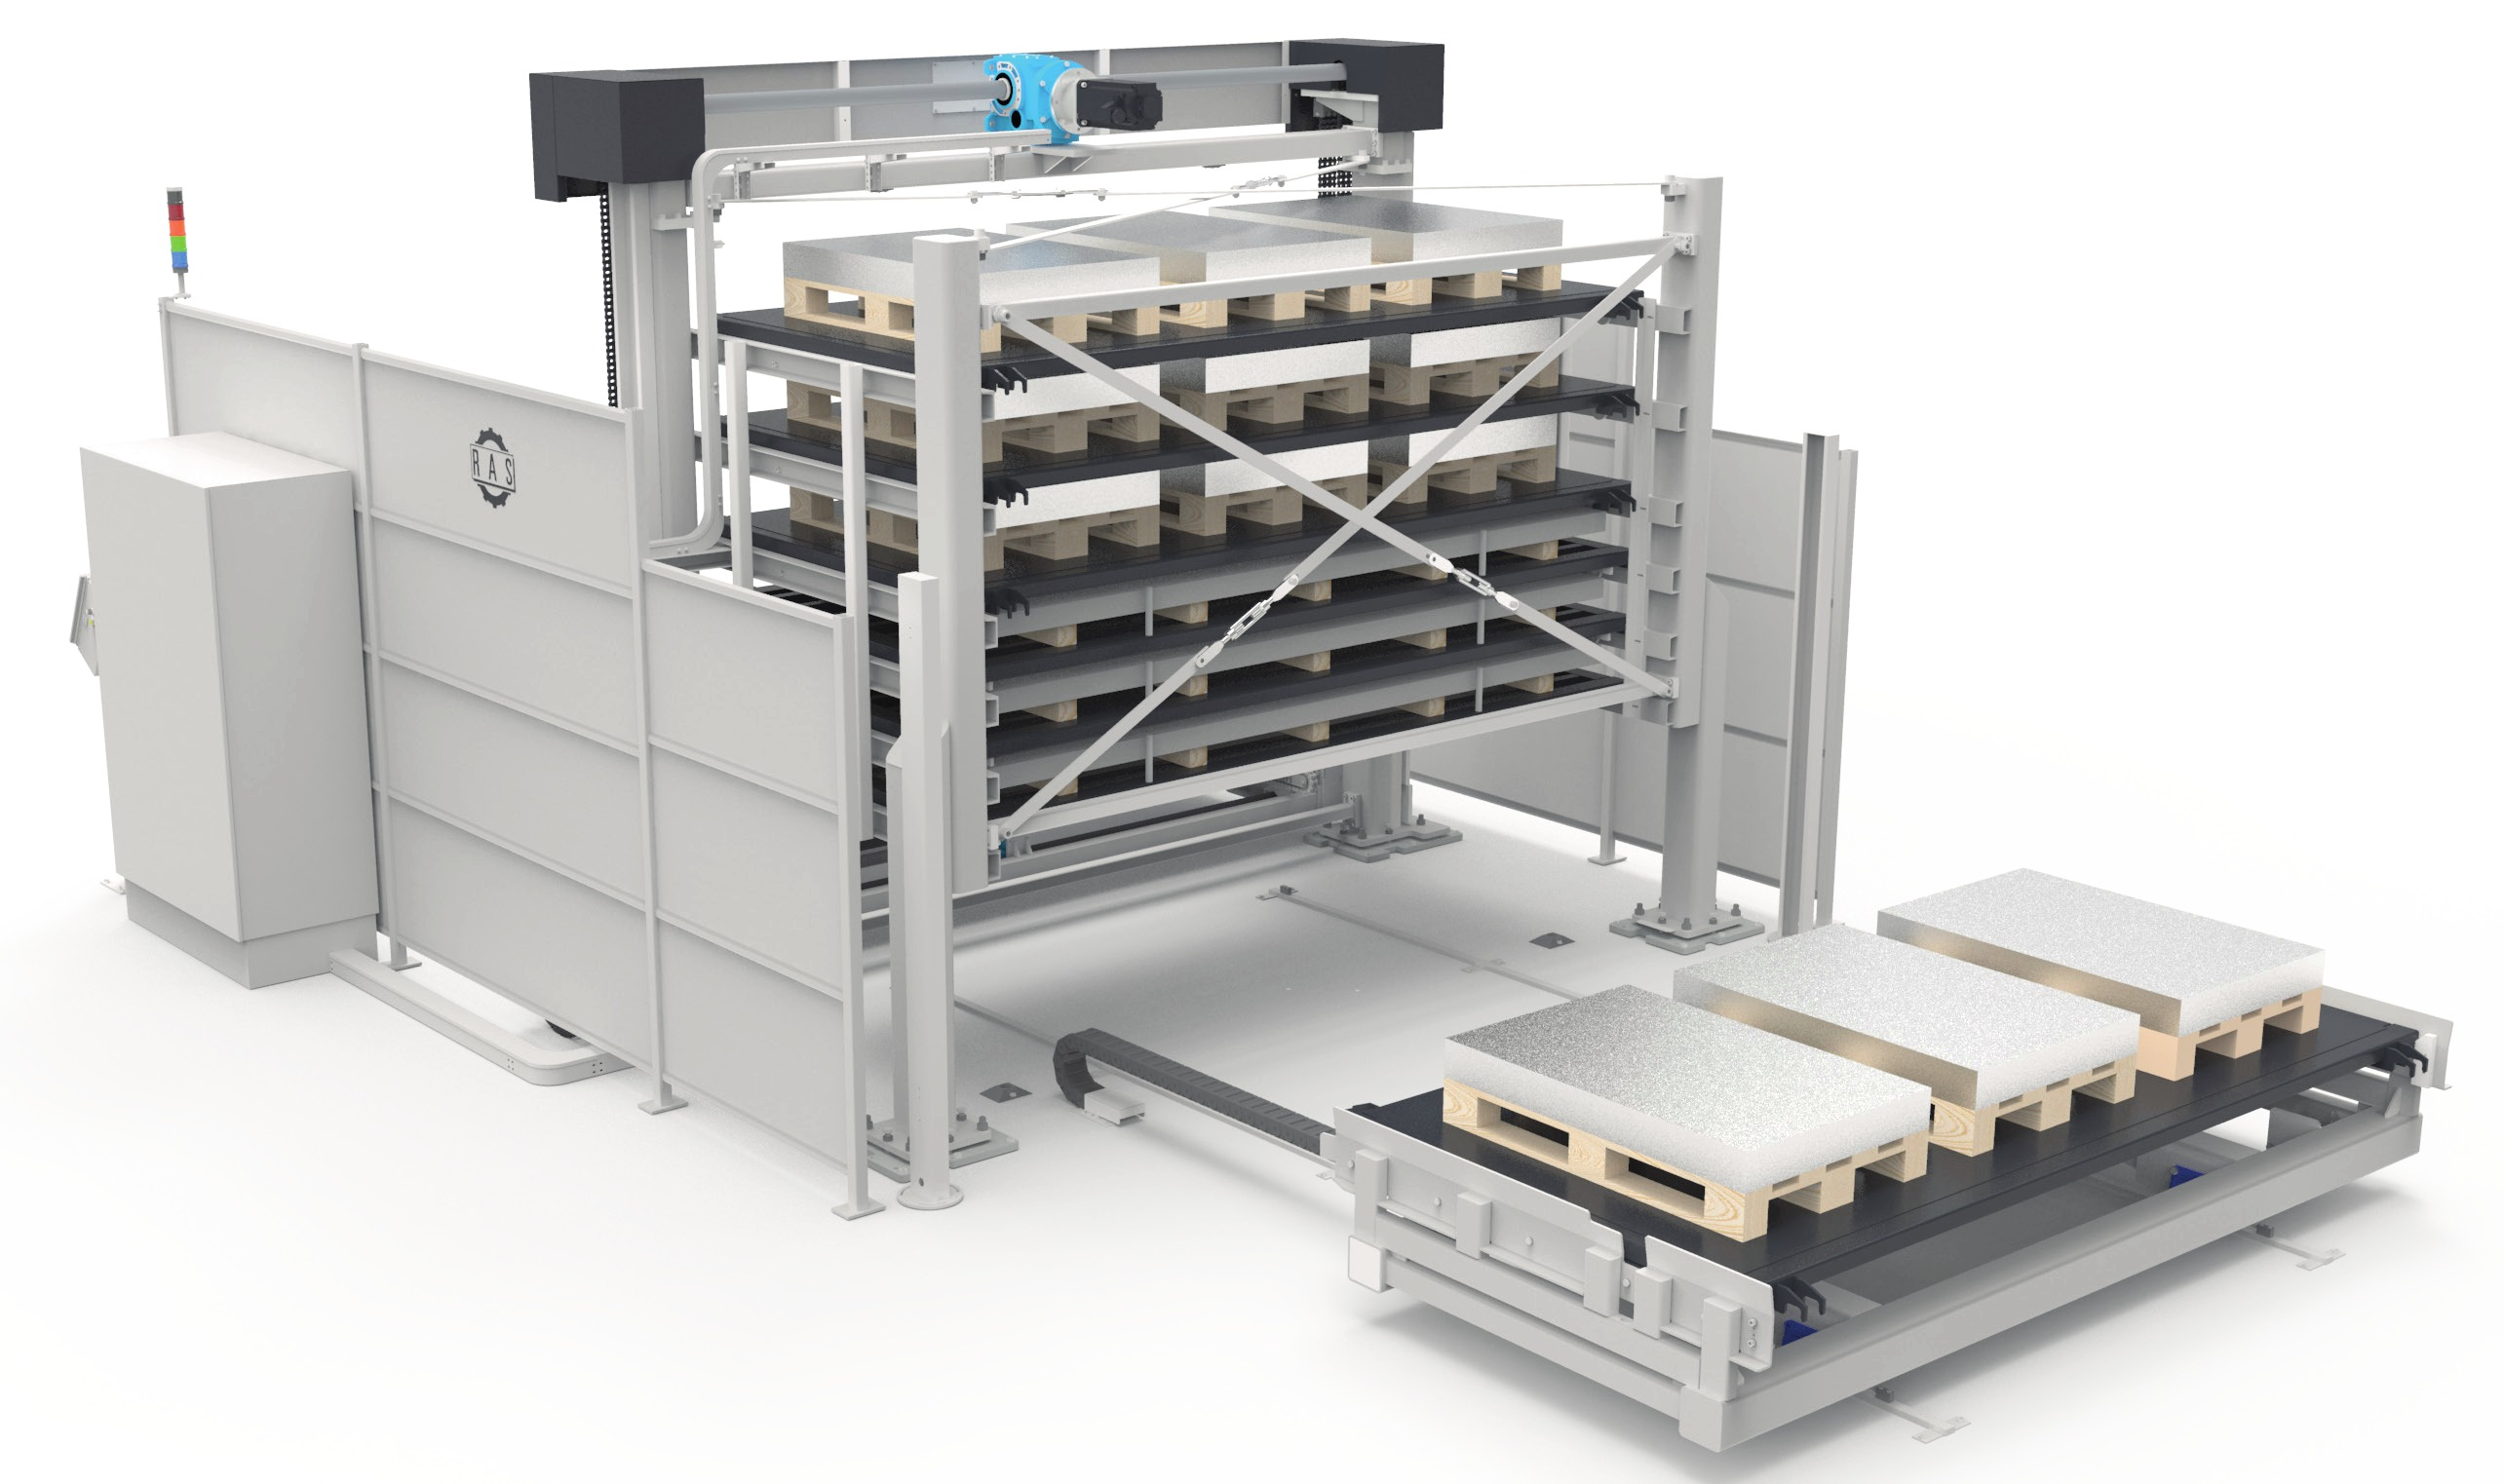
RAS-Storage_Tower.jpg: The compact RAS Storage tower with six pallets.
Source: RAS Reinhardt Maschinenbau GmbH

Contact:

RAS Reinhardt Maschinenbau GmbH
Richard-Wagner-Str. 4-10
71065 Sindelfingen
Germany

+49-7031-863-0
Sales@RAS-online.de
www.RAS-online.de

Press contact:
Romina Klingler
Marketing Manager
klr@ras-online.de
+49-7031-863-171
RAS Reinhardt Maschinenbau GmbH
Richard-Wagner-Str. 4-10
71065 Sindelfingen

