Press Release
Sindelfingen, October 20, 2026

Smart Predict detects wear before it brings the Multibend-Center to a standstill
AI-based condition monitoring prevents unplanned downtime and targets 99 percent machine availability.
RAS Reinhardt Maschinenbau GmbH is now offering Smart Predict, an AI-based predictive maintenance solution for the Multibend-Center. The system continuously analyzes the machine's sensor data, detects unusual patterns, calculates the probability of an impending failure and issues early warnings with recommended actions. This allows users to respond early, plan maintenance in advance and avoid unplanned downtime. Smart Predict is available as an option and can also be retrofitted to existing machines. At EuroBLECH 2026 in Hanover, visitors can find out more about the solution at the RAS booth (Hall 11, Booth B154).
Five sensors at critical points
The sensors are fitted to the most heavily loaded assemblies of the Multibend-Center: the upper beam gearbox, the folding beam gearbox, the upper beam drive, the main manipulator gearbox and the hydraulic unit. Smart Predict analyzes data such as temperature, friction and shock loads. The update interval can be set to 15, 30 or 60 minutes, depending on the process.
Condition-based maintenance
Unplanned downtime is costly in any production environment, and even more so in automated production: if one machine fails, the entire process grinds to a halt. With Smart Predict, maintenance is based on the actual condition of the machine rather than on fixed intervals. Rising temperatures, increasing friction or unusual shock loads show up in the measured values before they cause a failure. Spare parts can be ordered early and service work can be scheduled outside production hours. The target is 99 percent machine availability.
Clear interface, expandable platform
The user interface shows the condition of each measuring point at a glance, with limit values highlighted in the chart. Several machines can be monitored in parallel in a single view. If required, the system can be connected to existing ERP, MES and quality systems. The algorithms are continuously analyzed and become more accurate as more data is collected.
The Multibend-Center at a glance
The Multibend-Center is the automatic folding system from RAS. It changes tools without operator intervention, and Bendex Office generates the bending programs directly from the CAD data. It is available with bending lengths of around 2 to 3 meters for sheet thicknesses of up to 2 mm. Depending on the level of automation, it is loaded manually, by gantry loader, by robot or with the MiniFeeder.
(2,406 characters incl. spaces, 370 words)

About RAS:
RAS Reinhardt Maschinenbau GmbH is one of the world’s leading manufacturers of innovative sheet metal working machinery. Based in Sindelfingen, Germany, the company has stood for quality and technical precision “Made in Germany” for more than 85 years. Its extensive portfolio includes folding machines, swing beam shears and forming machines, as well as automated and customized manufacturing solutions for a wide range of industries worldwide. With a strong focus on quality, reliability and technological innovation, RAS delivers solutions that meet the most demanding requirements.
(585 characters incl. spaces, 84 words)

Links:
www.ras-online.de/en/service/smart-predict/
www.ras-online.de/en/products/bending/multibend-center/

Download area:
www.ras-online.de/en/press/

Images
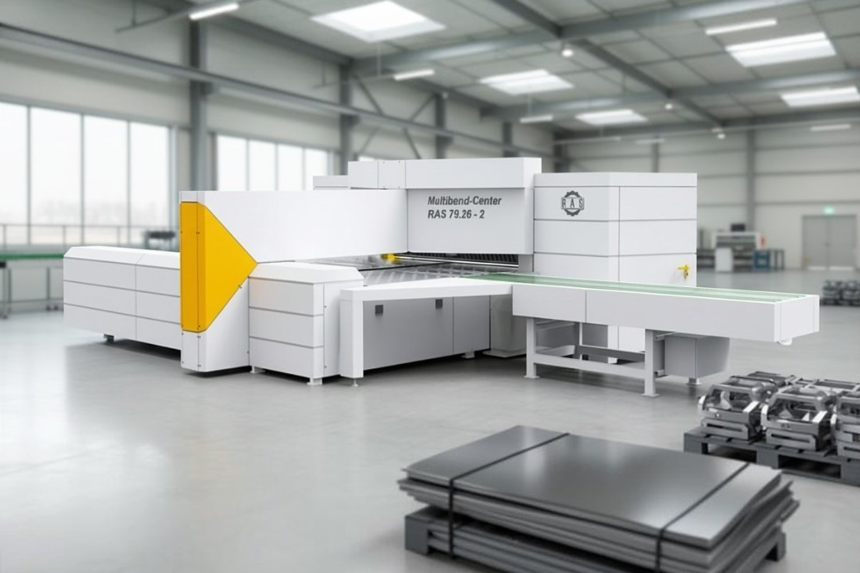
Multibend-Center_Smart-Predict.jpg: The RAS Multibend-Center bends sheet metal parts fully automatically. Smart Predict continuously monitors its gearboxes, drives and hydraulics.
Source: RAS Reinhardt Maschinenbau GmbH

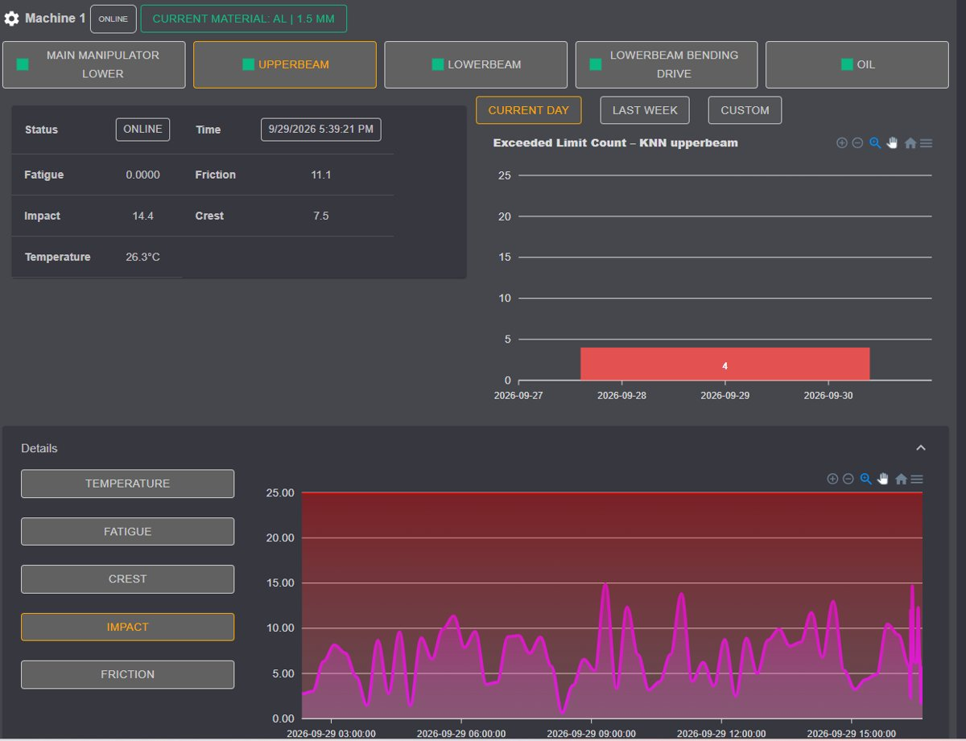
Smart-Predict_Dashboard.jpg: The Smart Predict interface, here showing the shock load (Impact) at one measuring point over the course of a day. Limit values are marked in red.
Source: RAS Reinhardt Maschinenbau GmbH

Contact for readers:
RAS Reinhardt Maschinenbau GmbH
Richard-Wagner-Str. 4-10
71065 Sindelfingen
Germany
+49-7031-863-0
Sales@RAS-online.de
www.RAS-online.de

Press contact:
Romina Klingler
Marketing Manager
klr@ras-online.de
+49-7031-863-171
RAS Reinhardt Maschinenbau GmbH
Richard-Wagner-Str. 4-10
71065 Sindelfingen

