Press Release

Sindelfingen, October 20, 2026
Two experts. One seamless line: RAS and Euromac present the Shear Multibend Center
New partnership at EuroBLECH 2026: punching, cutting and folding in one fully automatic line
With the Shear Multibend Center, RAS Reinhardt Maschinenbau and Euromac show at EuroBLECH 2026 what their new partnership makes possible. The line combines Euromac's punching and shearing technology with the RAS Multibend-Center and takes parts quickly and precisely from flat sheet to finished bent part.
From flat sheet to finished part. In one line.
Euromac and RAS each bring their core strength to the line: Euromac its punching and shearing technology, RAS its expertise in automated folding. The Euromac Load&Unload system picks the sheets straight from the stack and feeds them to the Shear XT, which punches and cuts the blanks. With no intermediate storage, the blanks pass directly into the bending cell, where the RAS Multibend-Center folds them fully automatically into finished parts. An optional robot can stack the parts at the end of the line, with no teaching or programming required.
Euromac Shear XT: punching and shearing in one machine
Combining punching and shearing, the Shear XT cuts formats up to 1,500 × 1,000 mm in just seconds, with very high precision and no micro-joints. Cutting lengths up to 3,000 mm are possible without repositioning. On average, the Shear XT achieves material savings of 15 to 20 percent and uses less energy than punching.
RAS Multibend-Center: fully automatic bending of precision parts
The RAS Multibend-Center bends precision parts fully automatically, regardless of batch size. All positive and negative bends are formed scratch-free and with high repeatability. It handles bending lengths up to 3,060 mm and part heights up to 203 mm. Fast tool changes allow a wide variety of parts, and the tools are built to last. Robot unloading and a pallet station are available as options.
See both machines live, side by side
At EuroBLECH in Hanover, Euromac and RAS will be exhibiting right next to each other from October 20 to 23, 2026: in Hall 11 at booth B153 (Euromac) and booth B154 (RAS). Euromac will show the Shear XT. RAS will exhibit the Multibend-Center ECO, an economical entry point into automated bending. It offers the full functionality of a bending center, with blanks and bent parts loaded and unloaded manually. At both booths, experts will explain how the complete line with the fully equipped Multibend-Center works.
(2,281 Characters incl. spaces, 371 words)
About RAS:
RAS Reinhardt Maschinenbau GmbH is one of the world’s leading manufacturers of innovative machines for sheet metal processing. Headquartered in Sindelfingen, the company has been renowned for over 85 years for its exceptional quality and technical precision, proudly representing "Made in Germany". The extensive portfolio includes folding machines, swing beam shears, forming machines, as well as automated and customized manufacturing solutions for various industries worldwide. With a strong focus on quality, reliability, and technological innovation, RAS delivers solutions that meet the highest demands.
(610 Characters incl. spaces, 83 words)

About Euromac:
Euromac S.p.A., based in Formigine, Italy, has been designing and building sheet metal working machines for around 40 years. Its range includes CNC punching machines, combined punching and shearing machines such as the Shear XT, electric and automatic press brakes and notching machines, complemented by software, automation solutions and service. www.euromac.com
(363 Characters incl. spaces, 51 words)

Deeplinks:
www.ras-online.de/en/euromac-and-ras/

Download-Area
www.ras-online.de/en/press/
Images
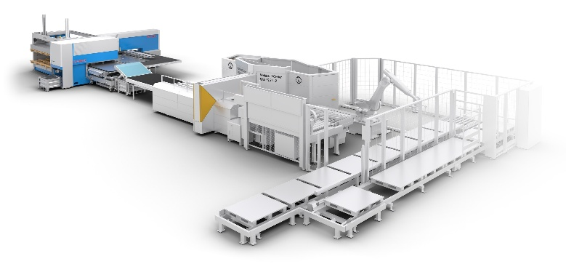
Shear-Multibend-Center_Linie.jpg: The Shear Multibend Center: Euromac Shear XT and RAS Multibend-Center in one line, from flat sheet to finished bent part, optionally with unloading robot.
Source: RAS Reinhardt Maschinenbau GmbH / Euromac

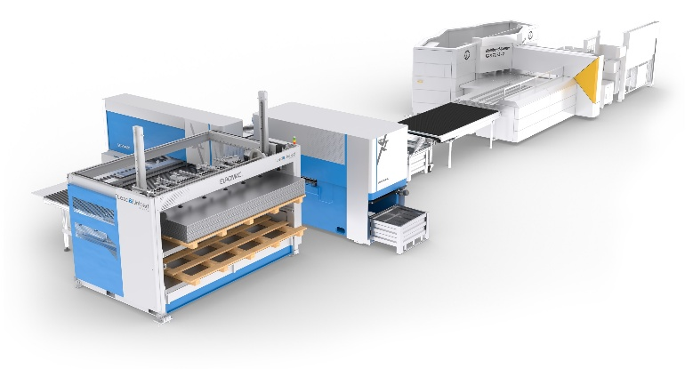
Shear-Multibend-Center_Gesamtansicht.jpg: Overview of the line: punching and shearing on the Euromac Shear XT, folding on the RAS Multibend-Center.
Source: RAS Reinhardt Maschinenbau GmbH / Euromac

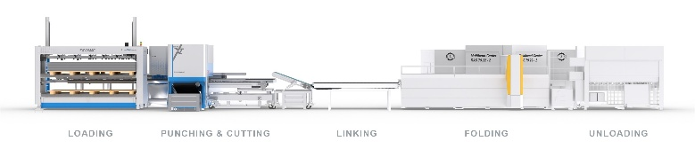
Shear-Multibend-Center_Stationen_EN.jpg: The Shear Multibend Center and its five stations: loading, punching & cutting, linking, folding and unloading.
Source: RAS Reinhardt Maschinenbau GmbH / Euromac

Contact:

RAS Reinhardt Maschinenbau GmbH
Richard-Wagner-Str. 4-10
71065 Sindelfingen
Germany

+49-7031-863-0
Sales@RAS-online.de
www.RAS-online.de

Press contact:
Romina Klingler
Marketing Manager
klr@ras-online.de
+49-7031-863-171
RAS Reinhardt Maschinenbau GmbH
Richard-Wagner-Str. 4-10
71065 Sindelfingen

