Press release
Sindelfingen, October 29, 2025

RAS presents the new XLTbend 2
More power, precision, and energy efficiency in sheet metal folding
At this year’s Blechexpo, RAS Reinhardt Maschinenbau GmbH presented the new XLTbend 2. An innovative folding machine that combines state-of-the-art technology, maximum precision, and outstanding energy efficiency.
With the XLTbend 2, RAS introduces a new generation of folding technology designed for precision, efficiency, and intelligent control. The machine is available in two versions with bending lengths of 3200 mm and 4060 mm, and depending on the model, it handles material thicknesses of up to 3 mm. This makes it highly versatile and perfectly suited for a wide range of sheet metal applications.
Precision through intelligent crowning system and automation
The intelligent crowning system ensures consistent and highly accurate bending results across the entire working length. In combination with the newly developed, optional robot integration and the powerful RAS automation solution LUNA, the XLTbend 2 enables fully automatic loading and unloading, which makes the production process significantly more efficient. With well-defined interfaces, the machine can be seamlessly integrated into existing production environments. This optimizes workflows and increases process reliability.
More energy efficiency with advanced drive technology
A key focus during development was on energy efficiency by replacing the four main drives from IE3 asynchronous motors with modern IE5 or higher servo drives. The result: more power, less energy consumption, and a clear contribution to cost-effective and environmentally conscious production.
The XLTbend 2 also impresses with a range of practical, application-oriented improvements. The 3-in-1 hybrid backgauge with increased suction power, combined with rear access to the bending line, provides greater safety, flexibility, and convenience when handling parts. In addition, the stronger folding beam stroke offers more power and expanded functionality for advanced bending operations.
With the new XLTbend 2, users benefit from outstanding precision, higher productivity, and a clear added value in their daily production processes.
(2.086 Characters incl. spaces)

About RAS:
RAS Reinhardt Maschinenbau GmbH is the world's leading manufacturer of innovative machines for sheet metal processing. Headquartered in Sindelfingen, the company has been renowned for over 85 years for its exceptional quality and technical precision, proudly representing "Made in Germany". The extensive portfolio includes folding machines, swing beam shears, forming machines, as well as automated and customized manufacturing solutions for various industries worldwide. With a strong focus on quality, reliability, and technological innovation, RAS delivers solutions that meet the highest demands.
(602 Characters incl. spaces)

Deep links:
www.ras-online.de/aktuelles/news/
www.ras-online.de

Download-Area
www.ras-online.de/en/press/

Images:
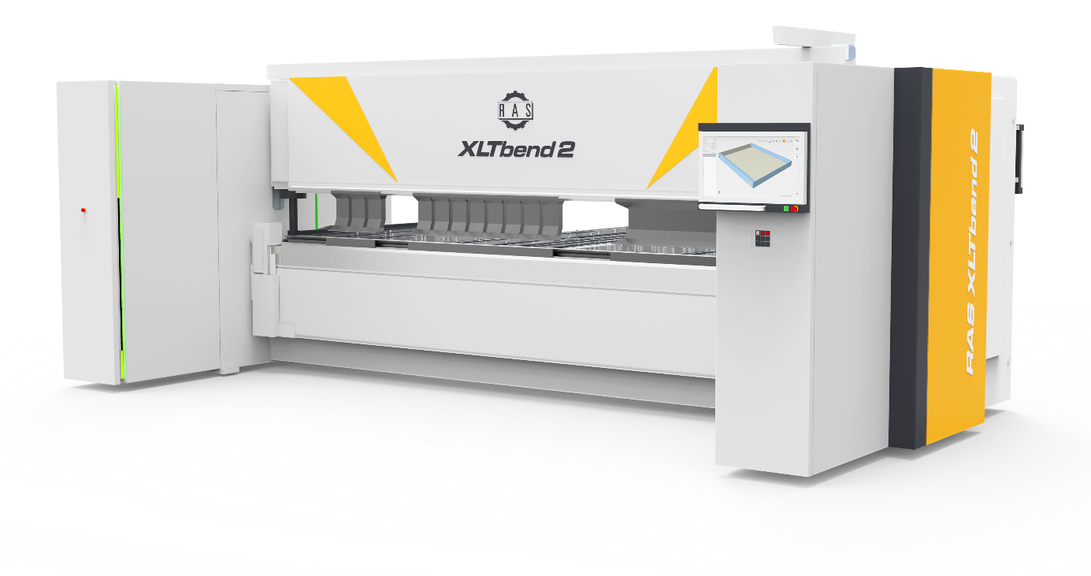XLTbend2.jpg: This innovative folding machine represents maximum precision, advanced drive technology and outstanding energy efficiency, available with bending lengths of 3200 and 4060 mm.
Source: RAS Reinhardt Maschinenbau GmbH

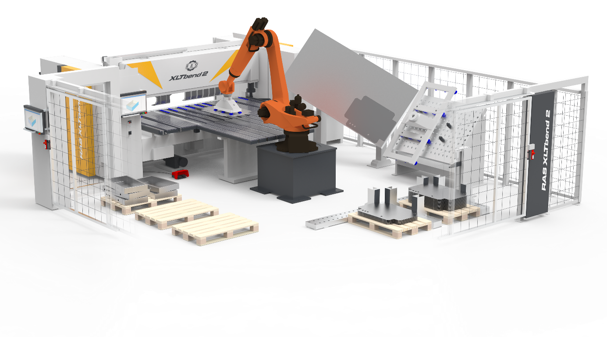XLTbend2 mit Roboter.jpg: Together with the RAS automation solution LUNA, the XLTbend 2 enables fully automated loading and unloading.
Source: RAS Reinhardt Maschinenbau GmbH

Contact:

RAS Reinhardt Maschinenbau GmbH
Richard-Wagner-Str. 4-10
71065 Sindelfingen
Deutschland

+49-7031-863-0
Sales@RAS-online.de
www.RAS-online.de

Press contact:
Romina Klingler
Marketing Managerin
klr@ras-online.de
+49-7031-863-171
RAS Reinhardt Maschinenbau GmbH
Richard-Wagner-Str. 4-10
71065 Sindelfingen

