***Press Release***

*Sindelfingen, August 19, 2025*

**RAS presents innovations in bending**Automation at a new level

**At the Blechexpo in Stuttgart, RAS Reinhardt Maschinenbau GmbH will showcase how modern bending technology and intelligent automation seamlessly go hand in hand. The company's booth in Hall 1, Stand 1604 will feature three powerful systems, including a new machine that sets new standards for automated bending.**

In addition to the proven models MinibendCenter 2 and Multibend-Center ECO, visitors will experience a special highlight: the premiere of the XLTbend 2. As the direct successor to the successful XLTbend, it has been specifically developed for automated applications and is equipped for the first time with an interface for robot integration.

**Premiere: Fully automated bending with robot integration**With the new XLTbend 2, RAS sets new standards in large part production, such as boxes and panels. The extended capabilities of the manipulator, modern safety features, energy-efficient IE5 servo drives, and an increased bending stroke for expanded functionality make the XLTbend 2 significantly more powerful and flexible than the previous version. Thanks to clearly defined interfaces and RAS's own automation solution LUNA, the machine can be seamlessly integrated into existing production environments.

**Compact. Efficient. Proven.**The MinibendCenter 2 is primarily designed for companies looking to economically, fully automate and precisely process small parts starting from 50x40 mm. The Multibend-Center ECO offers the full functionality of a high-end bending center with an exceptionally attractive price-performance ratio. Available in an automated version, it convinces with efficient series production and easy handling.

The XLTbend 2 will be presented live for the first time at Blechexpo, offering visitors the chance to speak directly with RAS experts about automation strategies, integration, and practical application opportunities.

(1.852 Characters incl. spaces, 261 words)  
**Visit us at Blechexpo in Stuttgart, Hall 1, Stand 1604.**

**About RAS:**

RAS Reinhardt Maschinenbau GmbH is the world's leading manufacturer of innovative machines for sheet metal processing. Headquartered in Sindelfingen, the company has been renowned for over 85 years for its exceptional quality and technical precision, proudly representing "Made in Germany". The extensive portfolio includes folding machines, swing beam shears, forming machines, as well as automated and customized manufacturing solutions for various industries worldwide. With a strong focus on quality, reliability, and technological innovation, RAS delivers solutions that meet the highest demands.

(602 Characters incl. spaces, 81 words)

**Deeplinks:**

www.ras-online.de/en/products/bending/multibend-center-eco/  
www.ras-online.de/en/products/bending/minibendcenter-2/  
www.ras-online.de

**Download-Area**

www.ras-online.de/en/press/

**Images**

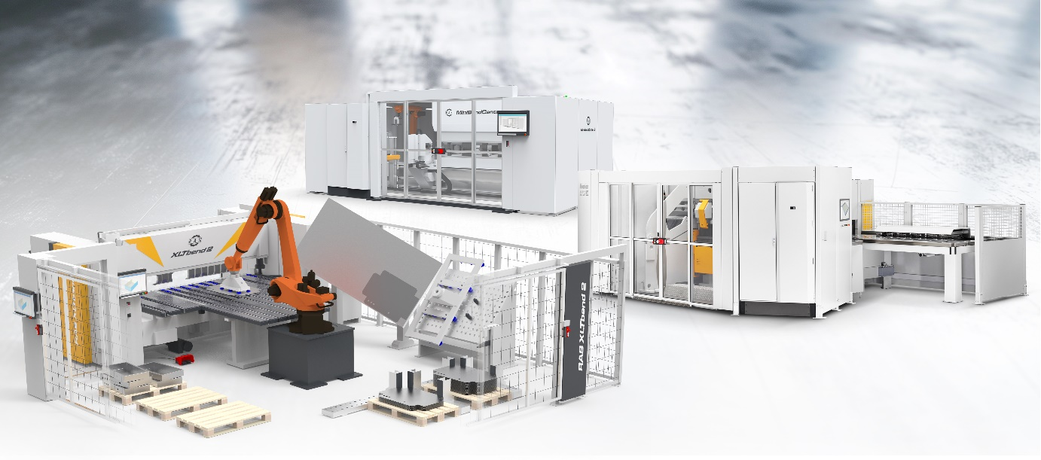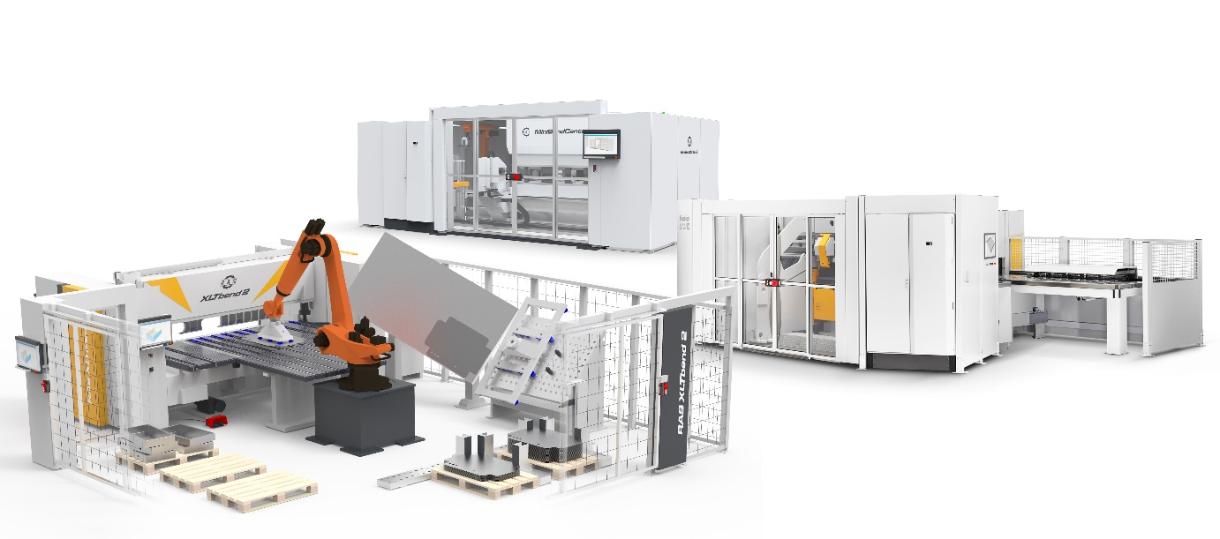

**XLT2, MiniBC2, MBCECO.jpg:** MinibendCenter 2, Multibend-Center ECO, and the new XLTbend 2 with robot integration. Three powerful systems for the future of automated sheet metal processing  
Source: RAS Reinhardt Maschinenbau GmbH

**Contact:**

**RAS Reinhardt Maschinenbau GmbH**

Richard-Wagner-Str. 4-10

71065 Sindelfingen

Deutschland

+49-7031-863-0

Sales@RAS-online.de

[www.RAS-online.de](http://www.RAS-online.de)

**Press contact:**

Romina Klingler  
Marketing Managerin  
klr@ras-online.de  
+49-7031-863-171

RAS Reinhardt Maschinenbau GmbH

Richard-Wagner-Str. 4-10

71065 Sindelfingen